WiFi timeSync

Sense weerstand

Moeilijke packages

* LGA
* BGA
* QFN

# Oplaadbeperktheden USB

USB levert 5V of electricity and allows your connected device to draw 500 milliampere.

Battery powerd devices should draw 500 mA, and not 100 mA. <http://www.testusb.com/power_issue.htm>

Door add-ons in USB 2.0 kan je zelfs tot 1.5 A gaan. <https://www.quora.com/How-much-power-does-a-USB-port-put-out>

# Battery: Panasonic NCR18650B

Maximale spanning: 4.2 V

Nominale spanning: 3.6 V

Minimale Spanning: 2.5 V (neem maar beter >= 2.75 V)

Max. oplaadstroom 1625 mA

# Charging: BQ24075

**Package:**

QFN-16

**Input pin:**

Connect IN to the external DC supply (AC adapter or USB port). The input operating range is 4.35 V to 6.6 V (BQ24072, BQ24073, BQ24075, and BQ24079) or 4.35 V to 10.5 V (bq23074).

**Output pin:**

OUT provides a regulated output when the input is below the OVP threshold and above the regulation voltage. When the input is out of the operation range, OUT is connected to VBAT except when SYSOFF is high (BQ24075 and BQ24079 only). Connect OUT to the system load. Bypass OUT to VSS with a 4.7-μF to 47-μF ceramic capacitor

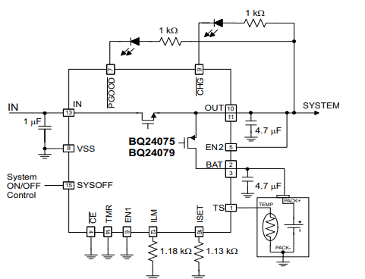

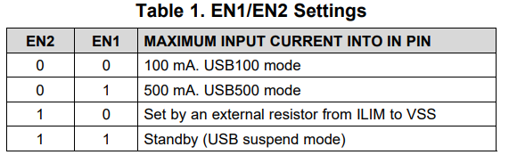

# Chargin: BQ242XX

Vast opladen met 500 mA

SPanningsverschil tussen in- en uitgang van max 500 mV.

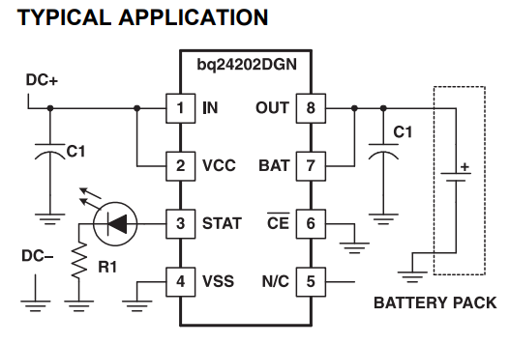

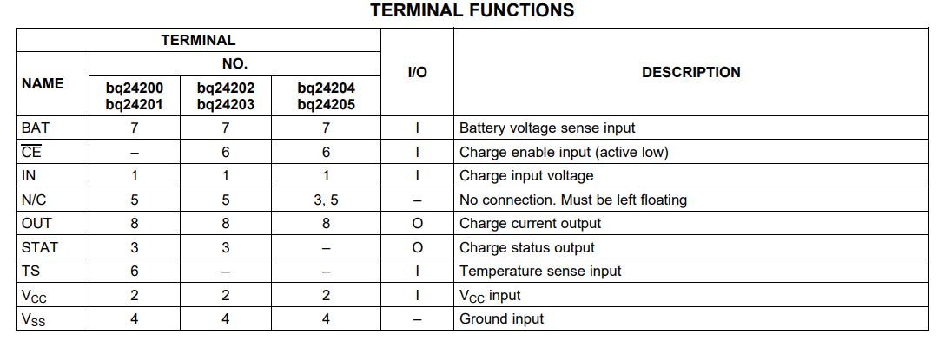

# Battery protection: BQ297XX

BQ2970

WSON

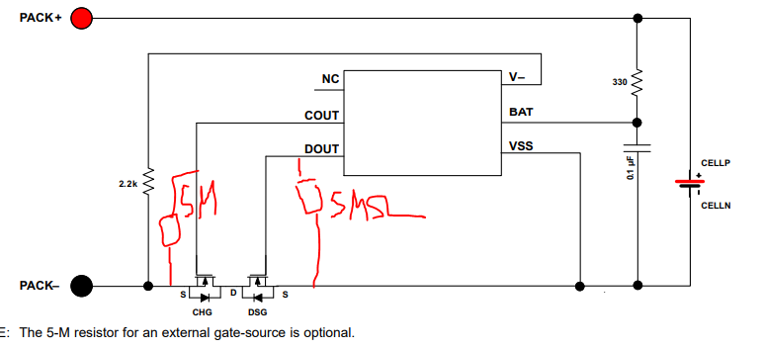

# Battery protection: S-8240A Series

S-8240ADZ-M6T1U

SOT-23-6

# Dual N-channel enhancement mosfet:

* CSD85301Q2
* FDS9926A (battery protection)
  + RDSON = 30 [mOhm @VGS=4.5 V](mailto:mOhm@VGS=4.5V)
  + Total gate charge = 6-9 nC